DT-BDU User Manual

DT-ENG-BDU-V1

20160617

1.About DT-BDU Unit
Discription:
The BDU unit is bus amplifier unit and networking component designed for DT
2-wire system. It has three work modes:Repeater mode, Router mode and
Gateway mode.

2. Terminal Description

DIP

6 5 4 3 2 1

2-Wire System
Model: BDU

Bus Amplifier

INDICATORS
Bus-IN
Bus-OUT
PA
PB
BUTTONS

OUT
DS
Tx/Rx
In-Use
NoRoute Amp-ON

IN
IN

DIP Setting:
Bit-1 to Bit-2 are used to BDU working modes setting.
Bit-3 to Bit-5 are used to address settings.
Bit-6 is used to video Impendence match.

-1-
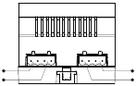

6 5 4 3 2 1

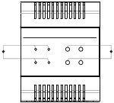

ON
ON

The detail settings of DIP are as follows:

INDICATORS:
1.Bus-IN: Always on when connect to net.
2.Bus-OUT: Always on when connect to monitor.
3.Tx/Rx: Flashes when communicating.
4.In-Use: Always off when in standby mode.

BUTTONS:
1.PA, PA: Video Amplifier Gain adjust.
2.NoRoute, Amp-ON: Debug button.

-2-
Bit | Bit State |  |  |  |  |  |  |  | Description
Bit-1~Bit-2 |  |  |  |  |  |  |  |  | Set to the Repeater mode.
Bit-1~Bit-2 |  | 1 2 3 4 5 6ON |  |  |  |  |  |  | Set to the Repeater mode.
Bit-1~Bit-2 |  |  |  |  |  |  |  |  | Set to the Router mode.
Bit-1~Bit-2 |  | 1 2 3 4 5 6ON |  |  |  |  |  |  | Set to the Router mode.
Bit-1~Bit-2 |  |  |  |  |  |  |  |  | Set to the Gateway mode.
Bit-1~Bit-2 |  | 1 2 3 4 5 6ON |  |  |  |  |  |  | Set to the Gateway mode.
Bit-1~Bit-2 |  |  |  |  |  |  |  |  | Reserved.
Bit-1~Bit-2 |  | 1 2 3 4 5 6ON |  |  |  |  |  |  | Reserved.
Bit-3~Bit-5 |  |  |  |  |  |  |  |  | Set to the first DT-BDU.
Bit-3~Bit-5 |  |  |  |  |  |  |  |  | Set to the second DT-BDU.
Bit-3~Bit-5 |  |  |  |  |  |  |  |  | Set to the third DT-BDU.
Bit-3~Bit-5 |  |  |  |  |  |  |  |  | Set to the fourth DT-BDU.
Bit-3~Bit-5 |  |  |  |  |  |  |  |  | Set to the fifth DT-BDU.
Bit-3~Bit-5 |  |  |  |  |  |  |  |  | Set to the sixth DT-BDU.
Bit-3~Bit-5 |  |  |  |  |  |  |  |  | Set to the seventh DT-BDU.
Bit-3~Bit-5 |  |  |  |  |  |  |  |  | Set to the eighth DT-BDU.
Bit-6 |  |  |  |  |  |  |  |  | Used to video Impendence match, set to ON.

1ON | 2 | 3 | 4 | 5 | 6

1ON | 2 | 3 | 4 | 5 | 6

1ON | 2 | 3 | 4 | 5 | 6

1ON | 2 | 3 | 4 | 5 | 6

1ON | 2 | 3 | 4 | 5 | 6

1ON | 2 | 3 | 4 | 5 | 6

1ON | 2 | 3 | 4 | 5 | 6

1ON | 2 | 3 | 4 | 5 | 6

1ON | 2 | 3 | 4 | 5 | 6

3. Working Mode Wiring.
3.1 Repeater Mode (Line amplifier):BDU can extend the distance of
DT system when works in repeater mode. As follows:
Max 140m from the first door station to BDU
Max 140m from the last indoor monitor to BDU

P C6

B

P C6

Repeater Mode

Wiring diagram:

B

DT-BDU

AC~

1 2 3 4 5 6
AC~

PC6

BDU

PC6

BUS(IM) BUS(DS)

OUT

DS

IN

IN

BUS(IM) BUS(DS)

-3-
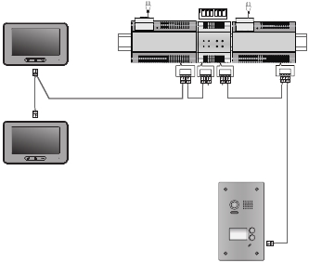

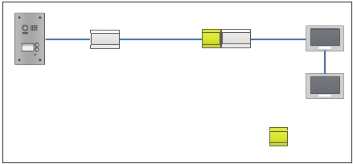

ON

3.2 Router Mode: In this mode, the system can connect up to 8
BDUs, and each BDU can connect up to 32 monitors.

4A

B

B

PC6

PC6

PC6

4A

4A

1
4
7
*
2
5
8
0
3
6
9
#

-4-

B

DT-BDU

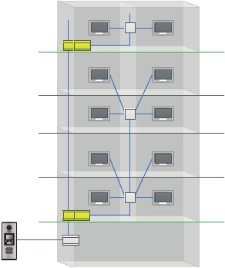

Wiring diagram:

NEXT
DBC4A

A B C D

AC~

NEXT
DBC4A

A B C D

AC~

DBC4A
PC6

BUS(IM) BUS(DS)
DBC4A
PC6

BUS(IM) BUS(DS)

AC~

1 2 3 4 5 6
1 2 3 4 5 6

BDU

BDU

PC6

OUT

DS

IN

IN

OUT

DS

IN

IN

BUS(IM) BUS(DS)

-5-

1
4
7
*

2
5
8
0

3
6
9
#
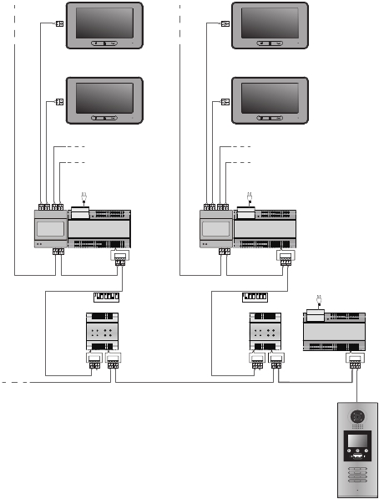

ON
ON

3.3 Gateway Mode: In this mode, the first door station can call all
the monitors and can connect up to 8 BDUs, and each BDU can
connect up to 32 monitors.

4A

4A

4A

4A

PC6

B

B

PC6

PC6

1
4
7
*

2
5
8
0

3
6
9
#

-6-

4A
B

DBC4A
DT-BDU
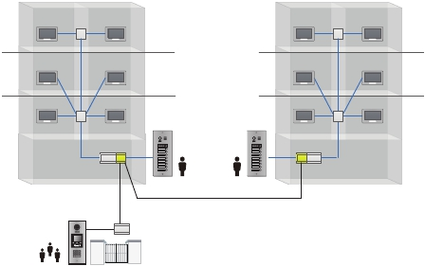

Wiring diagram:

NEXT
DBC4A

A B C D

AC~
NEXT
DBC4A

A B C D

AC~

DBC4A
PC6

BUS(IM) BUS(DS)
DBC4A
PC6

BUS(IM) BUS(DS)

AC~

1 2 3 4 5 6
1 2 3 4 5 6

BDU

BDU

PC6

OUT

DS

IN

IN

OUT

DS

IN

IN

BUS(IM) BUS(DS)

-7-

1
4
7
*

2
5
8
0

3
6
9
#
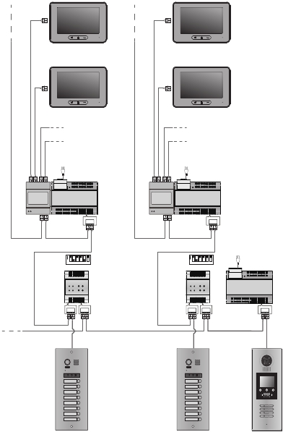

ON
ON

4. Specification

· Power Supply :
· Power consumption:
· Working Temperature:
· Wiring:
· Dimension:

DC24V;
Standby 13.5mA; Working 156mA;
-150C~+550C;
2 wire,non-polarity;
90(H)×72(W)×60(D)mm.

The design and specifications can be changed without notice to the user. Right to interpret
and copyright of this manual are preserved.

