PC6B Power Combo Instructions

1. Introduction:
The PC6B is a power combo unit, which is designed for
DT 2 wire system to supply power for outdoor station,
indoor monitor and other accessories. It can work both
as a normal power combo and auxiliary power combo. The
features are as follows:
· Universal AC input/full range
· Multi protection: short circuit, overload, over voltage
· Integrated with DT-DPS(power separator), Additional
DT-DPS is not needed.
· Support up to 4~8 monitors(depend on models)

4. Wiring:
Open the AC cover:
1. push the cover bottom
towards the center with
your hand;
2. turn over and pull it out.
After connect the AC cable,
it is suggested to close the cover.

AC Input

· DIN rail mounting

PG N

L

L
CN

1 2 3
2. Terminal Description:

PG N

L

L

CN

BUS(IM) BUS(DS)

1 2 3

LED
Connect to monitor
Connect to door staiton

PG

N

L
100~240 Vac

L

Note:
1. the AC cable is not included in the package, it must

2. pin1&2 should be short-circuited with a C3-3P
line(included in the package) if the unit work as a nor-
mal power combo. But if it work as a auxiliary power
BUS(IM) BUS(DS)

PG: Earth ground port.
N: AC input.
L: AC input.
LED: power indicator,always on when plug in power.
CN: bus control terminal.
BUS(IM): indoor monitor connection terminal.
BUS(DS): door station connection terminal.

3. Mounting:
Step1: Mount the din rail to the wall with screws ;
Step2: Pull down the mounting buckle,then hang the
unit on din rail.

Input Voltage:
Input Frequency:
Rated Output Voltage:
Rated Output Current:
Working Temperature:
SW Port Input Voltage:
Dimension:

6. Warning:

100~240Vac
50~60Hz
DC 26V+2V
1.5A
-200C~550C
Max.230Vac, 2A
140*90*60mm

Mounting Buckle

Din rail

Din rail
- The unit can only be used in DT 2 wire products sup-
plied by our company.
- Don’t connect the unit with any non-speci ed power
source. Fire or electric shock could result.
- Don’t dismantle or alter the unit. Fire or electric shock
could result.
- The unit must be installed and wired by a quali ed
technician.
- Keep the unit away from water or any other liquid. Fire
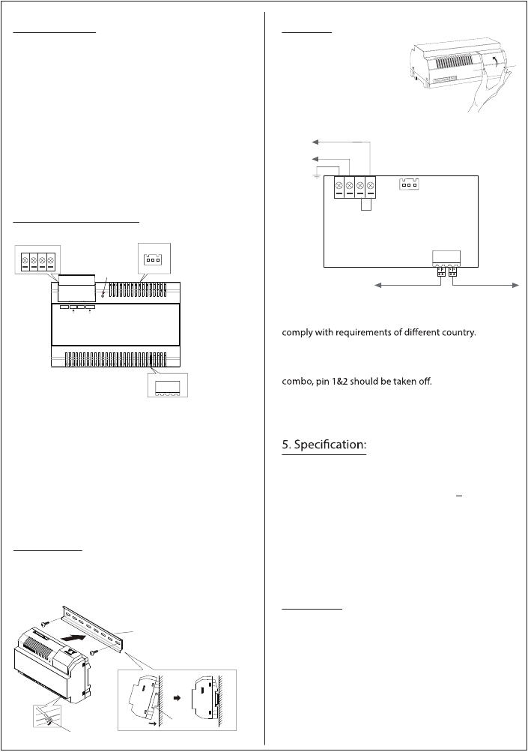
or electric shock could result.
*100~240Vac

