IP Gateway Converter Operating Instructions
Version 3.0 / 201812

1. Application:

DT-IPG is 2-Wire module which could use as a memory and divert module.
Without Internet:
As Memory Module provide video/picture memory for all monitor connected.
Support to link to ONVIF camera, could check IP Camera on 2-Wire monitor.
With Internet:
Divert calls to mobile from DT-IPG.

2. Terminal Description:

2-Wire System
Model: IPG-Gateway

IP Converter

Indicators
Power
In-Use
CHECK
CALL
Buttons

BUS(DS)

DIP Switch
Net
Video
DT-CHK IP-CHK
RJ45
BUS(IM)

Connection Port
RJ45: Network connection terminal.
BUS(IM): Indoor monitor connection terminal.
BUS(DS): Door station connection terminal.

:H UHVHUYH WKH ULJKW WR PRGLI\ WKH VSHFL¿FDWLRQ LQ WKLV PDQXDO DW DQ\ WLPH ZLWKRXW QRWLFH

-1-
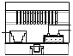

1 2 3 4 5 6

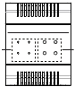

ON

3. Indicators:

On DT-IPG, there are DIP Switches, Buttons and Indicator LEDs for setup
DT-IPG, bellows are some generally explains.

DIP Switch:
When DIP Switches all in OFF position, means DT-IPG is in Dynamic IP ad-
dress.

When any DIP switches address, means DT-IPG is in Static IP address,
and DIP switch value is subnet address, range is 01~63. Please refer to the
followings in detail.

1 2 3 4 5 6
01

1 2 3 4 5 6
02

1 2 3 4 5 6
03

1 2 3 4 5 6
04

1 2 3 4 5 6
05

1 2 3 4 5 6
06

1 2 3 4 5 6
07

1 2 3 4 5 6
08

1 2 3 4 5 6
09

1 2 3 4 5 6
10

1 2 3 4 5 6
11

1 2 3 4 5 6
12

1 2 3 4 5 6
13

1 2 3 4 5 6
14

1 2 3 4 5 6
15

1 2 3 4 5 6
16

1 2 3 4 5 6
17

1 2 3 4 5 6
18

1 2 3 4 5 6
19

1 2 3 4 5 6
20

1 2 3 4 5 6
21

1 2 3 4 5 6
22

1 2 3 4 5 6
23

1 2 3 4 5 6
24

1 2 3 4 5 6
25

1 2 3 4 5 6
26

1 2 3 4 5 6
27

1 2 3 4 5 6
28

1 2 3 4 5 6
29

1 2 3 4 5 6
30

1 2 3 4 5 6
31

1 2 3 4 5 6
32

1 2 3 4 5 6
33

1 2 3 4 5 6
34

1 2 3 4 5 6
35

1 2 3 4 5 6
36

1 2 3 4 5 6
37

1 2 3 4 5 6
38

1 2 3 4 5 6
39

1 2 3 4 5 6
40

1 2 3 4 5 6
41

1 2 3 4 5 6
42

1 2 3 4 5 6
43

1 2 3 4 5 6
44

1 2 3 4 5 6
45

1 2 3 4 5 6
46

1 2 3 4 5 6
47

1 2 3 4 5 6
48

1 2 3 4 5 6
49

1 2 3 4 5 6
50

1 2 3 4 5 6
51

1 2 3 4 5 6
52

1 2 3 4 5 6
53

1 2 3 4 5 6
54

1 2 3 4 5 6
55

1 2 3 4 5 6
56

1 2 3 4 5 6
57

1 2 3 4 5 6
58

1 2 3 4 5 6
59

1 2 3 4 5 6
60

1 2 3 4 5 6
61

1 2 3 4 5 6
62

1 2 3 4 5 6
63

-2-
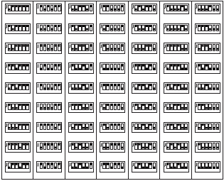

ON
ON
ON
ON
ON
ON
ON
ON
ON
ON
ON
ON
ON
ON
ON
ON
ON
ON
ON
ON
ON
ON
ON
ON
ON
ON
ON
ON
ON
ON
ON
ON
ON
ON
ON
ON
ON
ON
ON
ON
ON
ON
ON
ON
ON
ON
ON
ON
ON
ON
ON
ON
ON
ON
ON
ON
ON
ON
ON
ON
ON
ON
ON

Buttons:

Buttons function as below, you could also find more details on following
chapter.

Status
Buttons
CHECK

CALL

Press once
Copy picture and log to
SD card.
If test configure file exist
start auto-test.
If not divert once for test.

Press until “In-use” on

Press until “Video” on

Delete All call logs and
format SD card, twice to
confirm.

D T 2 - W i re d o o r s t a - *Long press 4 times to

DT-CHK
tions and monitor online initialize DT-IPG, format all

check.
data.

IP-CHK
Linked IP Camera quan-
tity check.
If update firmware exist
then update.
If not search IP Cameras.
Delete All linked IP cam-
eras, twice to confirm.

Indicator LEDs:

Indicators as below, you could also find more details on following chapter.

Status
LEDs
Power

In-use

Net

Video

off

No Power

Standby/No Power

Not connected

Standby/No Power

Solid On
Standby and power
on

Connected without
SIP registered
As video output

Quick flash

Checking IPC

Regularly flash

Starting

In auto-testing
Connected with
SIP registered
Recording/Play-
back

-3-
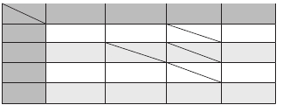

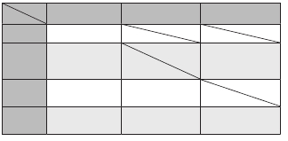

0RXQWLQJ
Step1: Mount the din rail to the

wall with screws;
Din rail

Step2: Pull down the mounting
buckle,then hang the unit on din
rail.

Din rail
Mounting Buckle
5. Wiring:

1 2 3 4 5 6
IP Address

2-Wire System
Model: IPG-Gateway
IP Converter

Power
In-Use
CHECK
CALL

Net
Video
DT-CHK IP-CHK

BUS(DS) BUS(IM)

To Monitors / Branch Distributor
To Door Station / Power Supply BUS(IM)
To Ethernet

6SHFL¿FDWLRQ

-4-
Power:
Consumption current:
LAN Ethernet:
Audio codec:
Video codec :
Network Protocol:

Operating temperature:
Dimension:
2-wire bus (26V, no-polarity)
Standby 109mA, maximum131mA
10BASE-T, 100BASE-TX
G.711(64Kbps)
H.264/AVC (VGA, QVGA)
IPv4, TCP, UDP, RTSP, RTP,
RTCP, IGMP, DHCP, NTP
0 °C ~ +40 °C
72*90*60mm
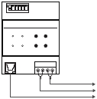

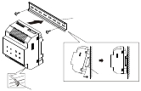

ON

