English

2-Wire Video Outdoor Station

User Manual

1
4
7
*

2
5
8
0

3
6
9
#

1
4
7
*

2
5
8
0

3
6
9
#

DT611/MK

DT611F/MK

DT-ENG-611(F)MK-V1 190307
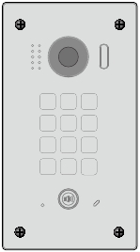

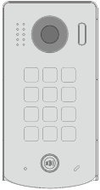

Contents

1.Parts and Functions............................................................................................. 1
2.Terminal Descriptions .......................................................................................... 2
3.Mounting.............................................................................................................. 2
4.System Wiring and Connections ......................................................................... 3
5. Pan-tilt & Zoom .................................................................................................. 8
6. Functions Setting Up .......................................................................................... 9
7.Unlock Operations ............................................................................................... 16
8.Specifications ...................................................................................................... 16
9.Cables Requirements .......................................................................................... 17
10.Precautions........................................................................................................ 18

1.Parts and Functions

[1]
[2]
[3]

1
2
3

4
7
5
8
6
9
[4]

*
0
#
[5]
[6]
[7]
30 mm

DT611/MK
[8]

[1]
[2]
[3]
Rainy Cover

1
2
3

4
7
*
5
8
0
6
9
#
[4]

[5]
[6]
[7]

[8]

DT611F/MK

Mounting box

[1] Camera lens
[2] LED_CAM
[3] Speaker

[4] KEY_MK
[5] LED_KEY
[6] Call button

-1-

[7] Microphone
[8] LED_POW
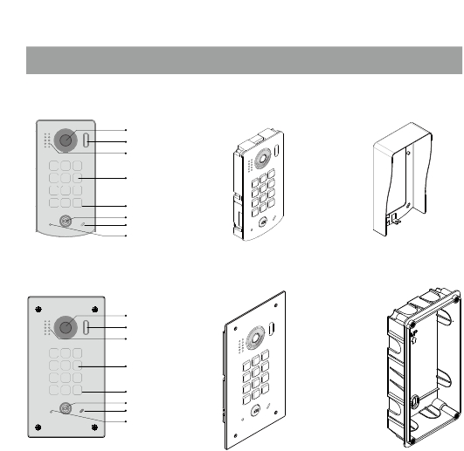

2.Terminal Descriptions

Lock Control Jumper

· Lock Control Jumper: To select the
lock type.
· Main Connect Port: To connect the
bus line and the electronic locks.

L1 L2

PL S1+

GND

Main Connect Port
· L1,L2: Connect to the bus line, no
polarity.
· PL: External lock power input, connect
to the power positive(power +).
· S1+,GND: Lock power connection
port.

3. Mounting

DT611/MK Mounting

1

Drill holes in the wall to match the size of
screws and attach the rainy cover to the wall.

3

Attach the panel to the rainy cover

-2-

2

4

Connect the cable correctly

Use the screwdriver and the screw
to fix the panel
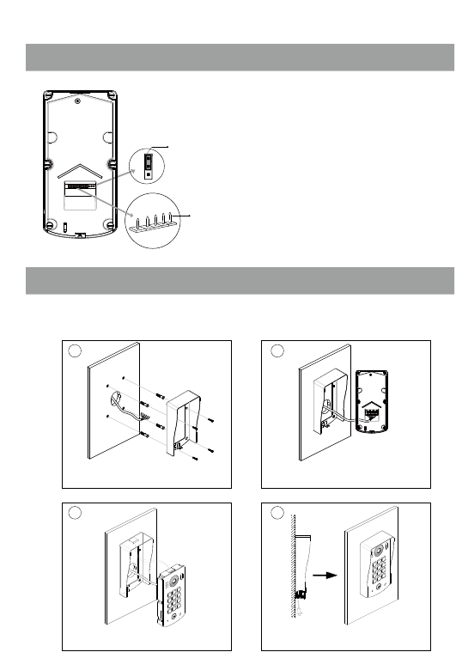

1 2 3

DT611F/MK Mounting

1

Drill a hole in the wall to match the size of the
mounting box and attach to the wall.

3

2

Connect the cable correctly

4

Attach the panel to the mounting box and
use screws supplied to fix the panel

4.System Wiring and Connections
Basic Connection

AC~

Code=00, DIP6=on

PC6A

L1
L2

DIP Switches

BUS(IM) BUS(DS)

L1

L2 PL S1+ GND

Doorbell Button

Switch
ON DIP
123456

-3-
-
+
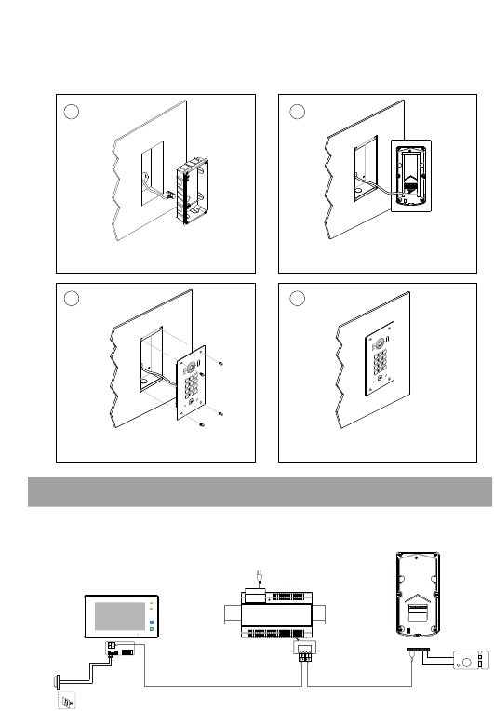

Electric Lock Connection
Door Lock Controlled with Internal Power

Note:
1. Electronic lock of Power-on-to-unlock type

1 2 3

2.
should be used.
The door lock is limited to 12V, and holding
Jumper position in 2-3

current must be less than 250mA.
L1
L2
PL
S1+
GND

3.

4.
The door lock control is not timed from Exit
Button(EB).
The Unlock Mode Parameter of Monitor
must be set to 0 (by default).

Door Lock Controlled with Dry Contact

Note:
* EB

LOCK

1.

2.
The external power supply must be used according
to the lock.
The inside relay contact is restricted to AC or DC
24V/1A.

L1

L2

PL
Take off the Jumper
S1+ GND

3.
4.
The jumper must be taken off before connecting.
Setup the Unlock Mode of Monitor for different
lock types.

· Power-on-to-unlock type:Unlock Mode=0
(by default)
· Power-off-to-unlock type:Unlock Mode=1

-4-
POWER
SUPPLY

LOCK

Unlock parameter setting(set in monitor)

· On main menu page, touch [Logo] icon to enter About page.

· When the screen stay in About page, press
seconds.
· A keypad is shown.
Refer to the followings:
UNLOCK button on front panel and hold for 2

00:10

DS-1

About

_

INSTALLER SETUP

123

Local Address
Video Standard
System Verson
Display Driver
Font
UI
00.00
AUTO
00.01.00
1.0
1.0
1.0
? + OK: Help Menu
@ + OK: Address Setting Menu

Note:
1.must connect DT611(F)/MK correctly before setting.
2.the parameter will be saved in DT611(F)/MK automatically,so you need only set on one monitor.

Multi Door Stations Connection

4# Camera
(Device Address:3)
3# Camera
(Device Address:2)
2# Camera
(Device Address:1)
1# Camera
(Device Address:0)

L1

L2

PL

S1+

GND

L1

L2

PL

S1+

GND

L1

L2

PL

S1+

GND

L1

L2

PL

S1+

GND

AC~
100~240VAC
A B C D

DBC4A1
PC6A

OFF
BUS(IM) BUS(DS)
ON
Impedance
switch

-5-
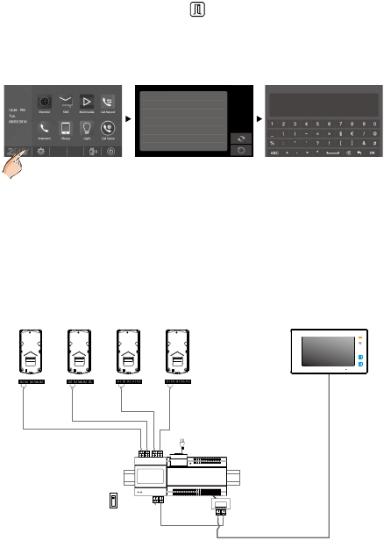

Multi Monitors Connection
Basic IN-OUT Wiring Mode

Code=15

Code=14

AC~

100~240VAC

PC6A

BUS(IM) BUS(DS)

Code=0

1
4
7
*

2
5
8
0

3
6
9
#

(Device Address:0)

-6-
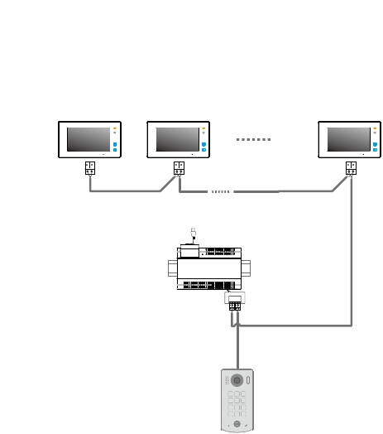

With DBC4A1 Wiring Mode

Code=14

Code=13

Code=2

Code=1

Code=15

Code=12

Code=3

Code=0

Impedance
switch

Impedance
switch

OFF ON

OFF ON

AC~
100~240VAC

PC6A

BUS(IM) BUS(DS)

1
4
7
*

2
5
8
0

3
6
9
#

(Device Address:0)

-7-
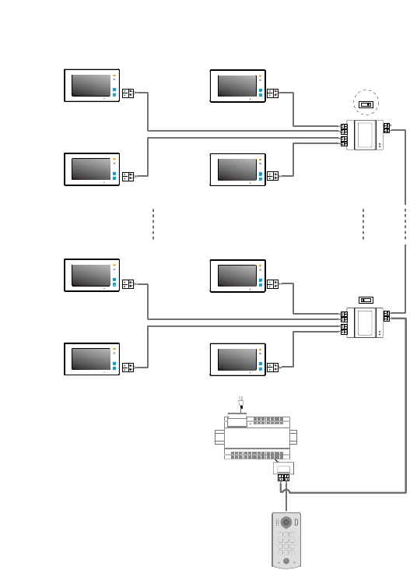

DBC4A1
DBC4A1
A B C D
A B C D

5. Pan-tilt & Zoom

Note that this function requires the monitor with fish-eye function to support.
It is available to adjust the display mode for viewing images at a fish-eye door station by using the 5
direction pad button.

When an image at a door station is displayed,move
to the desired position by touching
on the screen to view the image in zoom mode.

Note: The edge of pantilt image will not be displayed.

Screen of monitor

Here are some examples:

Touch
icon to zoom the center position.

-8-




6. Functions Setting Up

This section explains the settings of each function,please refer to the following table:
About the setting mode:
Input the master code to switch to the setting mode, and input the corresponding setting code to perform the
settings for the function you want. After settings have been made, input the following setting codes to continue the

setting operation. Press "
" to exit the setting mode.



· The example is set as cancel button and # as confirm button,please refer to */# function
setting for detail information.
· Forbid to slide to touch the digital keypad,it may cause mistaken key,the correct operation is
using your finger to press the digital you desired.
· You should press “confirm ”button after finish inputting the code number each
time,otherwise,the operation will be canceled automatically in 10s.

-9-
Order | Setting items | Setting range | Default value | Setting code
1 | Reset all settings | - | 1,2,3,4 | 00
2 | Setting the master code | 1 ~ 12 digitsValid keys:0 ~ 9 | 1234 | 01
3 | Setting the keyillumination time | 10 to 99 seconds/0(continually lit) | 10 seconds | 02
4 | Setting the unlock time | 1 to 99 seconds | 1 seconds | 03
5 | Setting the unlock mode | 0:opened/1:closed | opened | 04
6 | Operation tone settings | 0:on/1:off | on | 05
7 | Reset code settings | - | 1,2,3,4 | 06
8 | &# function settings | 0:Normal/1:Reverse | Normal | 07
9 | Language | Valid keys:0~9 | Enable | 08
10 | Voice Volume | Valid keys:0~9 | 5 | 09

-10-
11 | IMC Volume Adjust | Valid keys:0~9 | 7 | 10
12 | SPK Volume Adjust | Valid keys:0~9 | 4 | 11
13 | Device Address | Valid keys:0~3 | 0 | 12
14 | Night Light Level | Valid keys:0~5 | 4 | 13
15 | Reserve(not used) | Reserve | Reserve | 14~17
16 | Temporary(Single Useonly) Password forrelay1 | 1 ~ 12 digitsValid keys:0~9 | - | 18
17 | Temporary(Single Useonly) Password forrelay2 | 1 ~ 12 digitsValid keys:0~9 | - | 19
18 | Setting the code for usergroup 1 | 1 ~ 12 digitsValid keys:0~9 | - | 20~59
19 | Setting the code for usergroup2 | 1 ~ 12 digitsValid keys:0~9 | - | 60~99
20 | Work Mode | 0: Apartment/1:Villa | 1(villa) | 100
21 | Call Address | Valid keys: 0 - 9 | Villa:00,16Apartment:00~31 | 101

1

2

3

4
7
*
Input the master code.
5
8
0
6
9
#
Each operation is indicated by the lighting up of the LED_
POW , and by the sounding of the buzzer.

Status of LED_POW

(Default: [
] +[#] )
(white,slow flash)
Beep+, Beep

1.Reset all settings

Input the setting code.
00+#

Status of LED_POW

2.Setting the master code
(Default 1234)

Input the setting code.
01+#

Status of LED_POW

3.Setting the key
illumination time
(Default 10s)

Input the setting code.
02+#

Status of LED_POW

4.Setting the
unlock time
(Default 1s)

Input the setting code.
03+#

Status of LED_POW

(white,slow flash)
Beep+, Beep
(white,slow flash)
Beep+, Beep
(white,slow flash)
Beep+, Beep
(white,slow flash)
Beep+, Beep

Inputting of code
1234+#
Status of LED_POW

Inputting of new master code
(ex.: 4321)(1~12 digits)
4321+#
Status of LED_POW

Inputting of code (ex.: 10)
range:00 or 10~99
10+#
Status of LED_POW

Inputting of code (ex.: 09)
range:01~99
09+#
Status of LED_POW

(off)
Beep+
(white,slow flash)
Beep+
(white,slow flash)
Beep+
(white,slow flash)
Beep+

- When the “
mode.
- When there isn’t any operation in 10s, the LED_POW will off, the buzzer beeps, and the system exits the setting
mode.
- When setting failure, the LED_POW will off , the buzzer beeps rapidly.

Status of LED_POW
(off) Beep, Beep+

- All settings will restore to their
default value.
- When power on or activate
the reset all setting item,the
keypad checking will carry out,
during this time,the LED_POW
will on off on, and the touching
operation is forbidden, after finish
checking,the LED_POW will off
and sent out a long sound of beep

- The master code is allowed 1~12
digits,the same code cannot be set
for both the user code and the
master code,it is recommended
that you modify the default master
code.

- If the key illumination time is set
to 00,the key illumination will light
up all the time when power on.
- If the key illumination time is set to
10~99,the key illumination will light
up for 10~99 seconds.At this mode,
the key illumination lights off in
standby mode, touching any digital
key can illuminate,but this is the
invalid digital.

- The unlock time can be set on
both monitor and door station,
and the valid value is the number
you set last time.

-11-
* cancel” key is pressed, the LED_POW will off, the buzzer beeps, and the system exits the setting

Input the master code.

Status of LED_POW

(Default: [
] +[#])
(white,slow flash)
Beep+, Beep

5.Setting the unlock mode
(Default 0(opened))

Input the setting code.
04+#

Status of LED_POW

6.Setting operation tone
(Default ON)

Input the setting code.
05+#

Status of LED_POW

7.Reset code setting

Input the setting code.
06+#

Status of LED_POW

8. &# function setting
(Default Normal)

Input the setting code.
07+#

Status of LED_POW

(white,slow flash)
Beep+, Beep
(white,slow flash)
Beep+, Beep
(white,slow flash)
Beep+, Beep
(white,slow flash)
Beep+, Beep

0/1
Inputting of code (ex.: 1)
range:0:(open)/1:(close)
1+#
Status of LED_POW

0/1
Inputting of code (ex.: 1)
range:0:(on)/1:(off)
1+#
Status of LED_POW

Inputting of code
1234+#
Status of LED_POW

0/1
Inputting of code (ex.: 1)
range:0:(normal)/1:(reverse)
1+#
Status of LED_POW

(white,slow flash)
Beep+
(white,slow flash)
Beep+
(white,slow flash)
Beep+
(white,slow flash)
Beep+

- When the “
mode.
- When there isn’t any operation in 10s, the LED_POW will off, the buzzer beeps, and the system exits the setting
mode.
- When setting failure, the LED_POW will off , the buzzer beeps rapidly.

Status of LED_POW
(off) Beep, Beep+

- The unlock mode can be set on
both monitor and door station,
and the valid value is the number
you set last time.

- When the operation tone is
set to 0,pressing the digital
keypad will sent out a sound
of beep.
- When the operation tone is
set to 1,pressing the digital
keypad will blink one time.

- Cancel all the passwords except
the master code.
- Restore the master code to
default value(1,2,3,4)

- When the item is set to 0,press
the button to cancel the input,
and press the # button to confirm
the input.
- When the item is set to 1,press
the # button to cancel the input,
the input .

-12-

and press the * button to confirm
*
* cancel” key is pressed, the LED_POW will off, the buzzer beeps, and the system exits the setting
*

Input the master code.

Status of LED_POW

(Default: [

9. Language
(Default 2)
] +[#])

10.Voice Volume
(Default 5)
(white,slow flash)

11.IMC volume adjust
setting
(Default:7)
Beep+, Beep

12.SPK volume adjust
setting
(Default:4)

Input the setting code.
08+#

Status of LED_POW

Input the setting code.
09+#

Status of LED_POW

Input the setting code.
10+#

Status of LED_POW

Input the setting code.
11+#

Status of LED_POW

(white,slow flash)
Beep+, Beep
(white,slow flash)
Beep+, Beep
(white,slow flash)
Beep+, Beep
(white,slow flash)
Beep+, Beep

0/1

Inputting of code (ex.: 1)
range:0~9
1+#
Status of LED_POW
Inputting of code (ex.: 3)
range:0~9
3+#
Status of LED_POW
Inputting of code (ex.: 5)
range:0~9
5+#
Status of LED_POW
Inputting of code (ex.: 5)
range:0~9
5+#
Status of LED_POW

(white,slow flash)
Beep+
(white,slow flash)
Beep+
(white,slow flash)
Beep+
(white,slow flash)
Beep+

- When the “
mode.
- When there isn’t any operation in 10s, the LED_POW will off, the buzzer beeps, and the system exits the setting
mode.

Status of LED_POW
(off) Beep, Beep+

- When setting failure, the LED_POW will off , the buzzer beeps rapidly.

- Unlock via password is still available even when the door station is
talking.
- When door station is talking, you can enter the Master code (the
LED turns white upon that) to activate the volume adjusting function:
MIC adjustment: 1 (up), 4 (down);
Sleaker adjustment: 3 (up), 6 (down).

-13-

* cancel” key is pressed, the LED_POW will off, the buzzer beeps, and the system exits the setting

Input the master code.

Status of LED_POW

(Default: [
] +[#])
(white,slow flash)
Beep+, Beep

13. Device address setting
(Default 0)

Input the setting code.
12+#

Status of LED_POW

14.Night light level
setting
(Default 4)

Input the setting code.
13+#

Status of LED_POW

15.Temporary(Single
Use only) Password
for relay1

Input the setting code.
18+#

Status of LED_POW

16.Temporary(Single
Use only) Password
for relay2

Input the setting code.
19+#

Status of LED_POW

(white,slow flash)
Beep+, Beep
(white,slow flash)
Beep+, Beep
(white,slow flash)
Beep+, Beep
(white,slow flash)
Beep+, Beep

0/1

Inputting of code (ex.: 1)
range:0~2
1+#
Status of LED_POW
Inputting of code (ex.: 3)
range:0~5
3+#
Status of LED_POW
Inputting of code (ex.: 1006)
1~12 digits
1006+#
Status of LED_POW
Inputting of code (ex.: 2011)
1~12 digits
2010+#
Status of LED_POW

(off)
Beep+
(white,slow flash)
Beep+
(off)
Beep+
(white,slow flash)
Beep+

- When the “
mode.
- When there isn’t any operation in 10s, the LED_POW will off, the buzzer beeps, and the system exits the setting
mode.
- When setting failure, the LED_POW will off , the buzzer beeps rapidly.

Status of LED_POW
(off) Beep, Beep+

- Device address Settings:
0(device address:0),1(device
address:1),2(device address:2),
3(device address:3).

- Night Light Level:0~5.
-The higher the number, the
brighter the night lights.

- When input the correct temporary password to release the door,
the system will clear the temporary password after 60 seconds
automatically.But you should know that the password is valid within
60 seconds after inputing the correct temporary password
- The temporary1 is used to release the first lock,and the temporary
2 is used to release the second lock(the second lock need external
device to support).
- If the password length exceeds 12 digits, the system will sent out
the sound of “beep,beep,beep,beep”,and the digitals you input before
will be cleared at the same time.
- The temporary code can not be set the same as the master code
and user code.

-14-

* cancel” key is pressed, the LED_POW will off, the buzzer beeps, and the system exits the setting

Input the master code.

Status of LED_POW

(Default: [
]+[#] )
(white,slow flash)
Beep+, Beep

17.Setting the code
for user group1

20~59
Input the setting code.
(ex.:21)

Status of LED_POW

18.Setting the code
for user group2

60~99
Input the setting code.
(ex.:60)

Status of LED_POW

19.Work mode setting
(Default:1/villa)

Input the setting code.
100+#

Status of LED_POW

20.Call address setting
(Default:villa:00,16;
apartment:00~31)

Input the setting code.
101+#

Status of LED_POW

(white,slow flash)
Beep+, Beep
(white,slow flash)
Beep+, Beep
(white,slow flash)
Beep+, Beep
(white,slow flash)
Beep+, Beep

Inputting of code (ex.: 2011)
1~12 digits
2011+#
Status of LED_POW

Inputting of code (ex.: 2012)
1~12 digits
2012+#
Status of LED_POW

Inputting of code (ex.: 1)
range:0(a partment)/1:(villa)
0+#
Status of LED_POW

Inputting of code (ex.: 1)
range:Valid keys: 0 - 9
0+#
Status of LED_POW

(white,slow flash)
Beep+
(white,slow flash)
Beep
(white,slow flash)
Beep+
(white,slow flash)
Beep+

- When the “
mode.
- When there isn’t any operation in 10s, the LED_POW will off, the buzzer beeps, and the system exits the setting
mode.
- When setting failure, the LED_POW will off , the buzzer beeps rapidly.

Status of LED_POW
(off) Beep, Beep+

- The user code group1 is used to release the first lock,and the user
code group2 is used to release the second lock(the second lock
need external device to support).
- The user code group1 and user code code group2 can contain
40 group passwords
- If the password length exceeds 12 digits, the system will sent out
the sound of “beep,beep,beep,beep”,and the digitals you input
before will be cleared at the same time.
- The user code can not be set the same as the master code and
temporary code.

- Work mode setting:
0(a partment)/1:(villa).

-15-

- When the work mode is villa,the
call address:00 or 16.
- When the work mode is a
partment, the range of call
address:00~31.

* cancel” key is pressed, the LED_POW will off, the buzzer beeps, and the system exits the setting
60+#
21+#

7.Unlock Operations
Unlocking of user code
When the registered user code has been input using the keypad (1~12 digits), the LED background
indicator lights up, the buzzer sounds,and the electric door strike is unlocked.(note that you should
press "#" button(if "#" button is set to confirm button) after input the unlock code)
· The time interval during which the button must be pressed is approximately 10 seconds. If the
time interval exceeds approximately 10 seconds, the input value will be cleared.
· If you make a mistake when inputting the user code,press the" cancel" button and input the user
code again.
· The release function is forbidden and the input operation is disabled for 60 seconds if 10 times
incorrect access codes are continuously attempted. During this time,the buzzer will continuously
sound about 8 times.


1. During calling,pressing "cancel" button can cancel the calling
2. If input the incorrect access code,the buzzer will sound of beep,beep,beep

8.Specifications

·
·
·

Power Supply :
Power Consumption:
Camera:

DC 24V ;
Standby 15mA; Working status 105mA;
Color CMOS, 2.0 Mega pixel

·
1/2.7’’ fisheye camera,1700 wide angle;

·
·
·
·
·
·
·
·
Unlocking time:
Lock Power supply:
Number of relay circuits:
Mounting:

Working temperature:
Dimension:

-16-
1~99s
12Vdc, 280mA(Internal Power);
2(the second lock need external device to support)
Surface mounting(DT611/MK)
Flush mounting (DT611F/MK)
-15ºC ~ +55ºC
182(H)×93(W)×44(D)mm(DT611/MK)
220(H)×120(W)×50(D)mm(DT611F/MK)

9.Cables Requirements

The maximum distance of the wiring is limited in the DT system. Using different cables may also affect the
maximum distance which the system can reach.

The farest monitor

monitor

with two or four monitors

monitor

monitor

DBC4A1

B

C
AC~
100~240VAC
When Monitor quantity < 20

BUS(IM) BUS(DS)

When Monitor quantity > 20

A

Note:If the monitor has been specified the distance,refer to the
parameter.

-17-

1
4
7
*

2
5
8
0

3
6
9
#
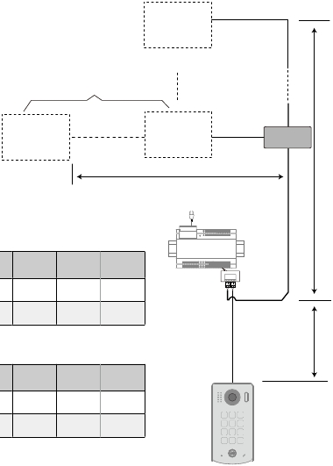

Cable Usage | A | B | C
2Twisted cable 2x0.75 mm | 60 | 60 | 30
2Twisted cable 2x1 mm | 80 | 80 | 40

Cable Usage | A | B | C
2Twisted cable 2x1 mm | 70 | 30 | 20
2Twisted cable 2x1.5 mm | 70 | 50 | 30

PC6A

10. Precautions
· Please clean the unit with soft cotton cloth, don't use the organic impregnant or chemical clean agent. If
necessary, please use a little pure water or dilute soap water to clean the dust.
· The unit is weather resistant. However do not spray high pressure water on access control keypad directly.
Excessive moisture may cause problems with the unit.
· You must use the right adaptor which is supplied by the manufacture or approved by the manufacture..
· Pay attention to the high voltage inside the products, please refer service only to a trained and qualified
professional.

The design and specifications can be modified without notice to the user. Right to interpret
and copyright of this manual are reserved.

DT-ENG-611(F)MK-V1 190307

-18-

